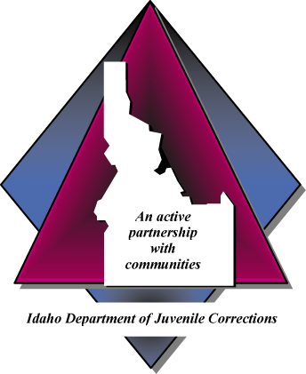

IDAHO DEPARTMENT OF JUVENILE CORRECTIONS

LICENSED PROVIDER CERTIFICATION

Section 1 Provider Certification Instructions

Section 2 Provider Certification Form

LICENSED EXTERNAL CLINICAL SERVICES
PROVIDER CERTIFICATION INSTRUCTIONS

Purpose
All licensed external clinical providers are required to submit the Provider Certification Form to the IDJC prior to providing services and upon renewal of the contract. All contracts are valid for one year. Certification requires the service provider to maintain professional licensure. The Provider Certification Form can be found at: http://www.idjc.idaho.gov.

Referrals
The IDJC cannot predict the caseload for the future and does not guarantee any particular volume of business.

Incomplete Information
The provider is responsible for all information contained in this certification. Please read all instructions carefully before submitting certification. Incomplete information may result in delays in processing, or may be returned as incomplete.

Contractor Performance and Financial Responsibility
Before renewing any contract, the IDJC reserves the right to consider previous performance and financial stability as these areas relate to the performance of the duties under the contract.

Submit certification & questions to Ben Stoddard
benjaminl.stoddard@idjc.idaho.gov
208.577.5457 Phone
Quality Improvement Services

Insurance Requirements and Proof
The IDJC requires insurance that covers your activities under the contract. This insurance is required for all providers of external clinical services. The contractor is responsible for ensuring that all subcontractors are covered by same limits of insurance for their activities under the contract. Please provide a copy of your insurance certificate with your certification.

Licensed Contractors with Direct Juvenile Contact
 | Workers Compensation | Amount:
 | Professional Liability | Amount:
 | General Liability Commercial | Amount:
 | Auto Liability | Amount:
 | Employers Liability | Amount:

Instructions
- The following must be submitted for certification:
  - Provider Certification Form
  - Copy of current licensure and/or credentials
  - Copy of insurance certificate
- Please submit a completed original of this certification.

LICENSED EXTERNAL CLINICAL SERVICES
PROVIDER CERTIFICATION FORM
Business Name: |  |  |  | Contact Person:
Address:
Phone: |  |  |  | Fax:
E-mail: |  |  |  | Website:
Licensing Entity:
Type of Service(s) Provided:
Sex Offender Treatment Psychosexual Evaluation Counseling GAIN Psychological Evaluation Polygraph Waiver/SSI Assistance
Other:

Treatment Model(s):

Signature: Date:
Signature indicates that the information I have provided is correct. I understand that any misrepresentations or incorrect information provided to the IDJC can result in certification rejection.

