**Instructions for using the IJOS JJ SUDS Authorization Form**

1. Sign in to IJOS and find the client record
2. Click on the **UTILITIES** menu at the top of the page. Choose **“MAIL MERGE DOCUMENT”.**

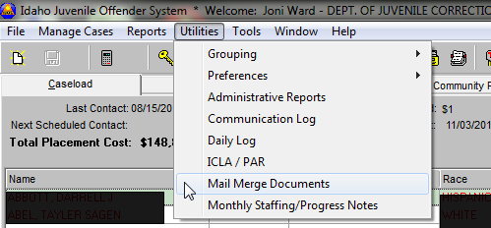

1. A pop up menu will open. Chose “**JJ SUDS AUTHORIZATION”** from the list. And Click the **RUN MAIL** MERGE button.

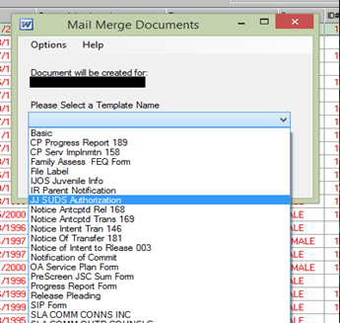

1. IJOS will open the form in Microsoft Word, with much of the information automatically populated for you.  You can SAVE the file or print from there. **Don’t forget to fill in the rest of the information, including the Start and End dates of authorization!**

