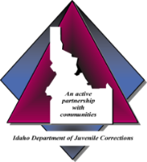
Idaho Department of Juvenile Corrections
COMMUNITY REINTEGRATION SERVICES MONTHLY SUMMARY/PROGRESS REPORT
(Restricted Information)
Instructions for Completing the Community Reintegration Services Monthly Summary/Progress Report
The Monthly Summary/Progress Report is due within 30 calendar days of the initiation of services, and at a minimum every 30 calendar days thereafter. The contractor must enter the appropriate “Service Code” to indicate the type of service provided. Each service must be recorded individually. Refer to the Service Level Agreement (SLA) regarding approved services for this juvenile. The contractor must enter the identified goal from the SLA that corresponds to the service code entered. This should include the specific competency the juvenile is expected to gain. The contractor must also list the progress toward the goal by describing the actions the juvenile is taking to meet the goal. When a goal is achieved, the contractor must enter the date the goal was achieved and summarize why the goal is considered complete. Service codes are located at the bottom of the page.

Month Of: | JSC: | Juvenile: | IJOS No:

Service  Code | Goal and Competency | Progress Toward Goal | Date Goal Achieved | Goal Completion Summary

Contractor Name: Contractor Signature: Date:
SERVICE CODES:
SC Service Coordination
SK Skills Training
TS Tracking Services
OT Other ______________________________

